**ASSIGNMENT NO:02**

**Title**

To identify major use cases,identify actors,write use case specification for all major use cases. Draw detailed use case diagram using UML2.0 natations.

**Objective**

1. To study the classification of diagrams.
2. To understand use case diagrams and study how to draw these diagrams using different notations in Umbrello.

**Theory**

**What is Classifications**

1) Classification helps to identify generalization,specialization, and aggregation hierarchies among

classes

2) Classification guides in making decisions about modularization

3) Coupling and cohesion also indicate a type of sameness

4) Classification also plays a role in allocating processes to processors

**Classifications of Diagrams**

**1.Structural diagrams**

show the **static structure** of the system and its parts on different abstraction and implementation **levels** and how they are related to each other. The elements in a structure diagram represent the meaningful concepts of a system, and may include abstract, real world and implementation concepts.

**2. Behavioral diagrams**

show the **dynamic behavior** of the objects in a system, which can be described as a series of changes to the system over **time**.

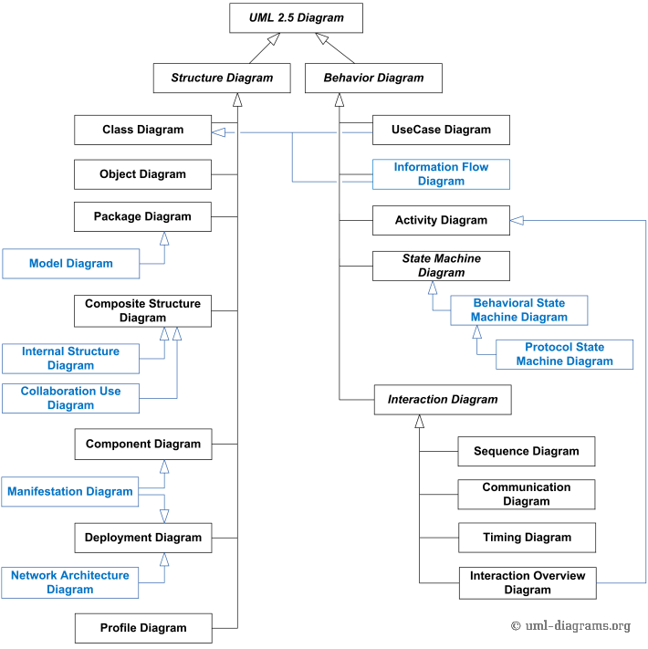

( Fig: Classification of diagrams )

**Use case Diagram**

A use case diagram is a graphic depiction of the interactions among the elements of a system.

A use case is a methodology used in system analysis to identify, clarify, and organize system requirements. Use case diagrams are employed in UML (Unified Modeling Language), a standard notation for the modeling of real-world objects and systems.

A use case diagram contains four components.Actor, use case, rela

**Notations/components**

**Actor:**

Actors are usually individuals involved with the system defined according to their roles. The actor can be a human or other external system.

**Use Case :**

A use case describes how actors uses a system to accomplish a particular goal. Use cases are typically initiated by a user to fulfill goals describing the activities and variants involved in attaining the goal.

**Relationship :**

The relationships between and among the actors and the use cases.

**System Boundary:**

The system boundary defines the system of interest in relation to the world around it.

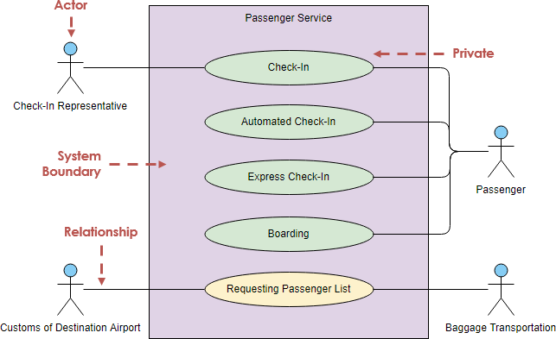

### **Special Features**

### **<<include>> Use Case**

The time to use the <<include>> relationship is after you have completed the first cut description of all your main Use Cases. You can now look at the Use Cases and identify common sequences of user-system interaction.

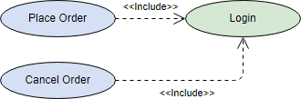

### 

### **<<extend>> Use Case**

An extending use case is, effectively, an alternate course of the base use case. The <<extend>> use case accomplishes this by conceptually inserting additional action sequences into the base use-case sequence.

UML Use Case Diagram Extend Use Case Example

### 

### **Abstract and generalized Use Case (Generalization)** The general use case is abstract. It can not be instantiated, as it contains incomplete information. The title of an abstract use case is shown in italics.

### **UML Use Case Diagram Generalization Example**

**Conclusion**

We studied and understood the classification of diagrams and designed use case diagram. We also developed the use case diagram using various notations like actor, use case,relationship and special features like include and extend too.